FUNCTIONAL REQUIREMENTS DOCUMENT
Digital Restaurant Menu & Service Platform
Prepared for stakeholder review and approval

1. Purpose of This Document
This document describes, in plain and simple language, what the new digital restaurant menu system will do. It is meant to give a clear picture of every feature so that it can be reviewed and formally approved before design and development begin.
The goal of the system is to replace paper menus and manual waiter calls with an easy, web-based menu that customers use directly from their table, using their own phone.

2. How a Customer Will Use the System
When a customer sits down at a table, they will follow four simple steps:
- Open the menu link and type in their table or seat number.
- Browse a clean, high-quality digital menu with photos and prices.
- Choose the items they want and save their order.
- The order is sent instantly to staff, who are notified in real time.

3. Customer-Facing Features
These are the features that customers will directly interact with while seated at the restaurant.
Table-Locked Access
Customers must enter their specific table or seat number before the menu unlocks. This keeps every order tied to the correct table.

Interactive Digital Menu
A beautiful, easy-to-browse menu where customers can view items, select what they want, and save their order directly to the system.

Service Call Buttons
Simple buttons customers can press to directly call a Waiter, a Hostess, or a Cleaner, without needing to flag anyone down in person.

4. Staff & Management Features
Restaurant staff and managers will have their own dedicated area of the system to manage orders and the menu itself.
Live Request Dashboard
A real-time screen showing every incoming order and service request as it happens, so staff can respond quickly.

Menu Management Tools
Staff can update menu items, change prices, upload new photos, and apply discounts or special offers at any time, without needing outside technical help.

Promotional Banners
A banner at the top of the menu page can be switched on for special occasions, such as New Year's or other celebrations, to highlight current offers.

5. Order Data & Storage
All orders and service requests are saved to the system's central database so nothing is lost while it is needed.
- To keep the system fast and running smoothly, old order data is automatically cleared out once a week, every Saturday.
- This weekly clean-up keeps storage costs low and ensures the system always starts the new week with a clean slate.

6. Next Steps
- Share this document with the stakeholder for review and formal sign-off.
- Prepare a few different visual design options for the digital menu, for the stakeholder to choose from.
- Begin development once the design and requirements are both approved.

7. Visual Process Flows
The diagrams below show the same information from the sections above, laid out step by step for anyone who prefers a visual walkthrough.

7.1 Customer Ordering Flow
The simple path a customer follows from sitting down to their food arriving.
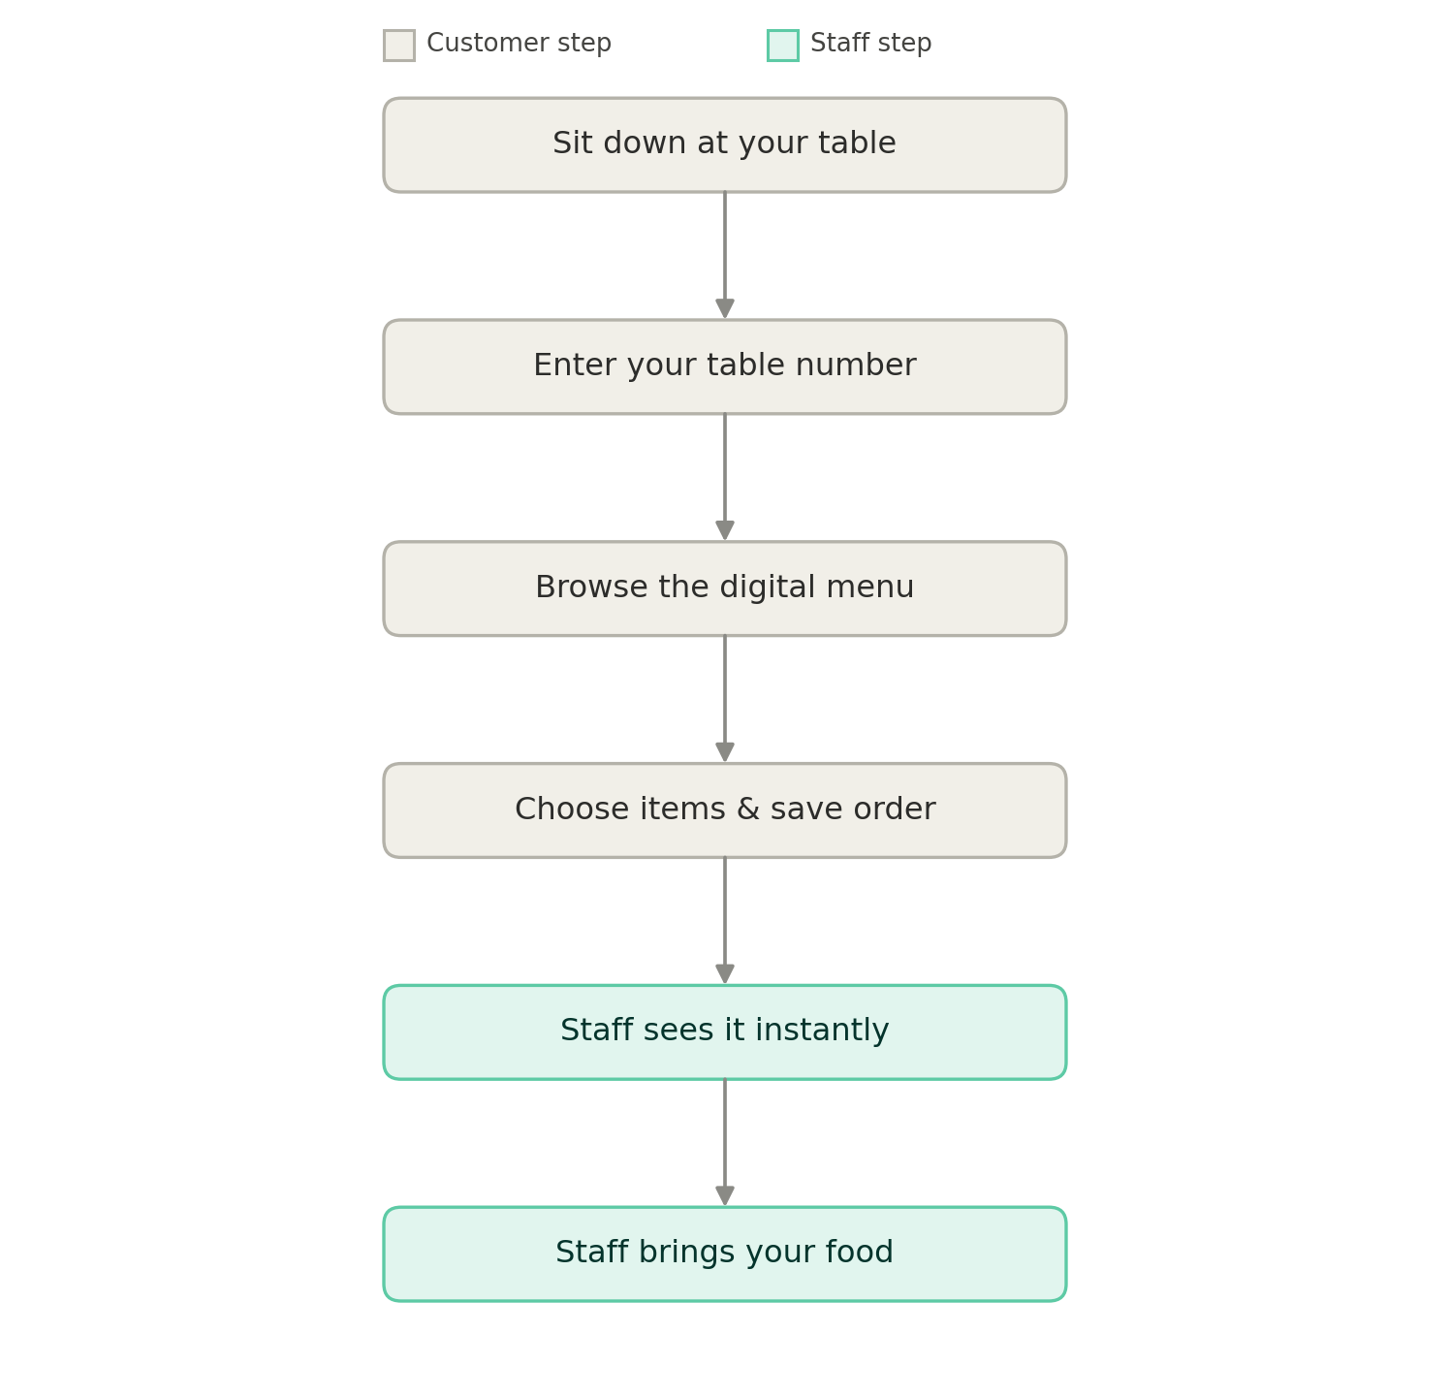
Figure 1 — Customer ordering flow, from table to food arriving.

7.2 Full System Flow (Including Service Calls)
A more detailed view showing both ways a customer can reach staff — placing an order, or pressing a service call button — plus the automatic weekly data cleanup.
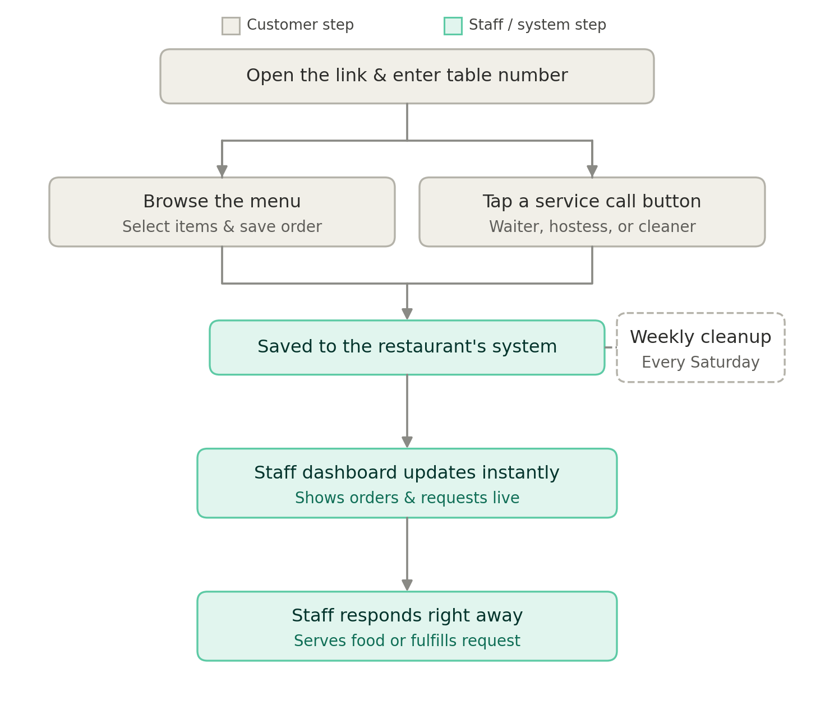
Figure 2 — Full flow from customer action through to staff response, including the weekly cleanup.

7.3 Admin & Menu Management Flow
How staff make changes to the menu — editing items, adjusting prices and discounts, updating photos, or turning on promotional banners — and how those changes reach the customer.
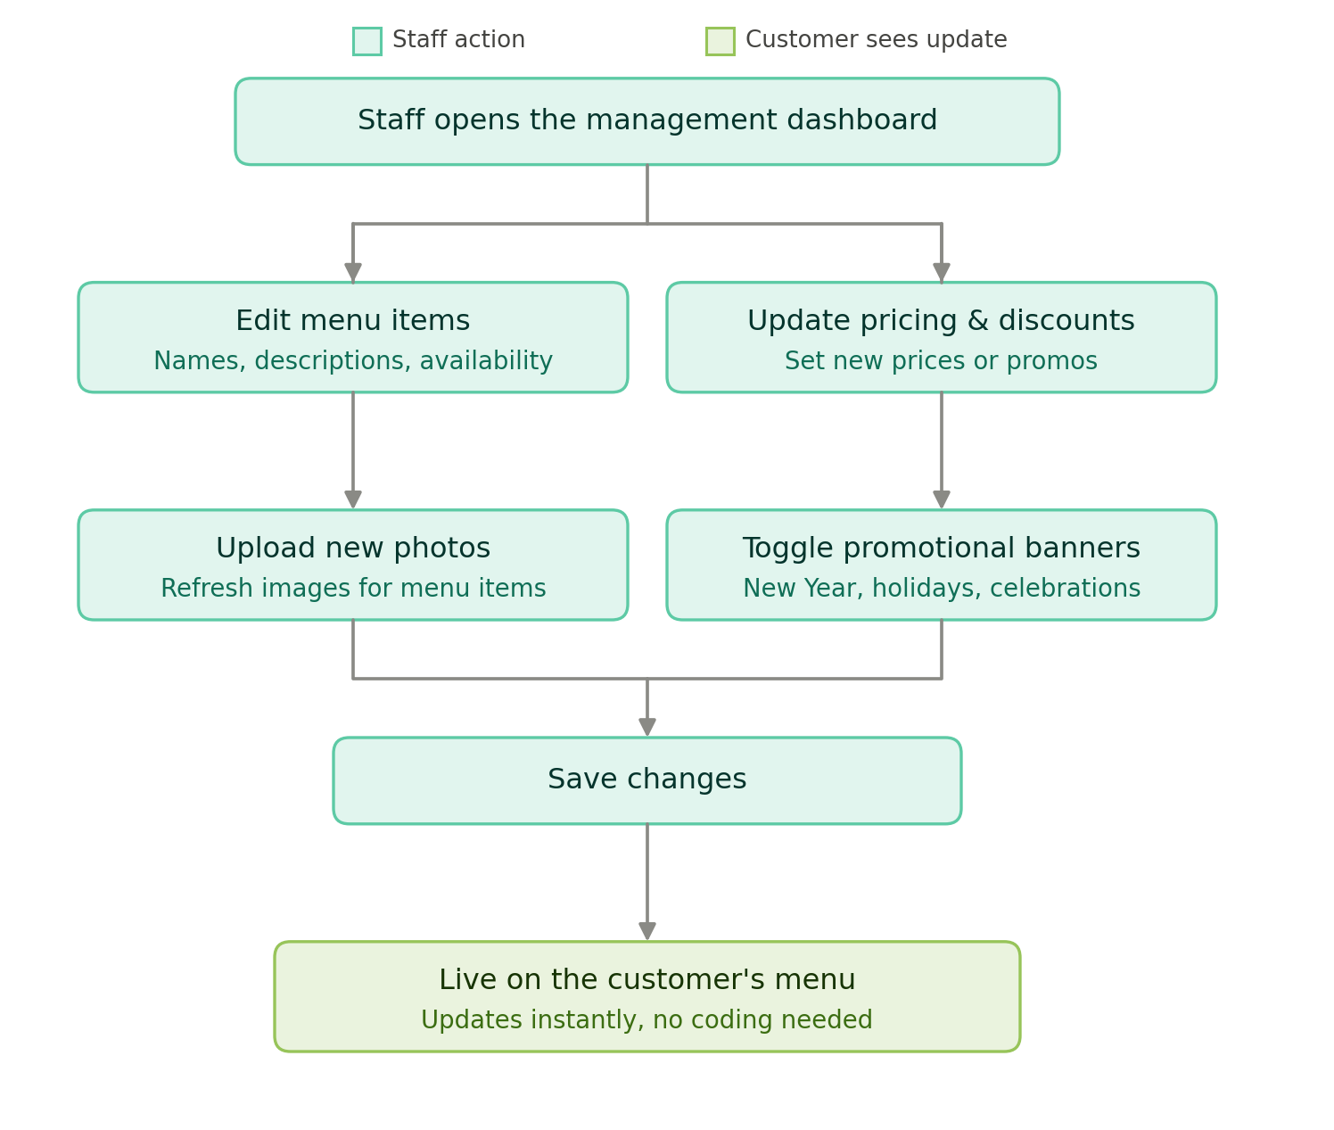
Figure 3 — Admin flow, from the management dashboard to the change appearing on the customer's menu.

Prepared by Owais · Digital Restaurant Menu & Service Platform

